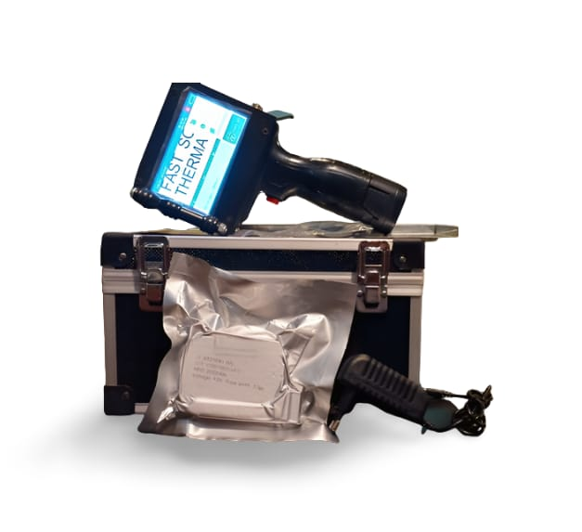

Hand Held Printer F-Series

Description

The F-Series Portable Handheld Printer is great for marking porous, semi-porous and non-porous substrates on the fly! The Handheld Inkjet Printer prints high resolution alphanumeric text, barcodes, logos and much more. The SNEED-JET Portable Handheld Printer comes equipped with built in counters for marking date and time codes, lot codes, batch codes and much more!

* Compact handheld printer. It’s ultra portable, lightweight and easy-to-operate
* Print with black, white, yellow, blue, red and green inks on various types of substrates
* Change colors in less than 30 seconds
* Print alphanumeric text, barcodes, logos, date / time codes, batch codes, counters and more
* 1-8 lines of programmable text
* HP® Technology with print heights ranging from 1.2mm to 12.7mm
* Lightweight handheld inkjet printer (2.6 lbs)
* Print anywhere, at any angle, without ink leakage
* Long lasting handheld inkjet printer battery (10 hours continuous print, 20 hours standby)
* Selectable languages include English, Spanish, Portuguese, Italian, Russian, Turkish, Arabic, Korean, Simplified Chinese and Traditional Chinese
* You can print other languages by creating message as a logo file
* High resolution font, barcodes and QR code
* Create and store up to 1,000 messages via USB
* Print up to 2,000 characters per message (no limitation on message length)

**F-Series**

**Portable Handheld Printer Versatility**

* The Handheld Inkjet Printer gives you versatility to print on porous, semi-porous and non-porous substrates
* Print black, white, yellow, red, blue, and green colors
* Change colors in less than 30 seconds
* Print on glass, plastics, metal, concrete, pipe, boxes and more
* Print on HDPE, LDPE, PETE, PET, PE, PP, PVS, PPC, OPP, APET and more

**Maintenance Free HP® Technology**

* The F-Series Portable Handheld Printer utilizes HP® print engine
* Each time you replace your ink cartridge you’re ultimately replacing your printhead
* No long term wear and tear compared to other stationary printheads
* Change ink cartridges (ink colors) in less than 30 seconds